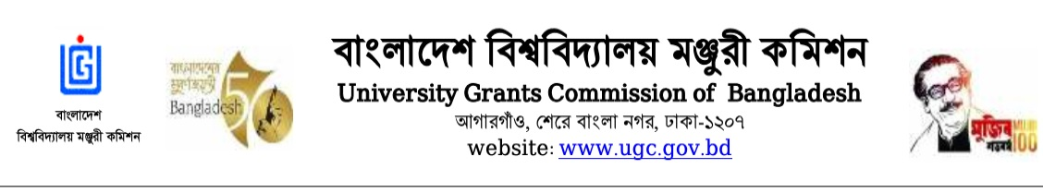
‘UGC PhD Fellowship-2022-23’
(Information Chart)
Note: This is a template format. Please edit your information in the table according to template.

Sl. No | Name of the candidate, Address, Mobile and Email | Degree achieved | Name of the Institute, Academic year, registration number and Date | Name of Supervisor, Address, Mobile number, Email and Number of students doing research (M.Phill/Ph.D) | Title of Research  (English/Bangla) | Publications | Remarks
1 | 2 | 3 | 4 | 5 | 6 | 7 | 8
01. | Name: Mohammad Rafiqul Islam  Designation:  Assistant Professor  Faculty & Department:  Faculty of Science  Dept. of Mathematics  Organization:  Bangabandhu Sheikh Mujibur Rahman Science and Technology University, Gopalganj  Mobile:  01702915694  Email: mribsmrstu@yahoo.com  Pay Order: 4472522 | MPhil: Awarded,  Khulna University of Engineering and Technology, Khulna, 2007  Master: First Class 3rd, Shahjalal University of Science and Technology, Sylhet, 1995  Bachelor: First Class 3rd  Shahjalal University of Science and Technology, Sylhet, 1994  HSC: Second Division,  Govt. Rajendra College, Faridpur, 1990  SSC: First Division,  Char Hazigonj High School, Faridpur, 1988 | PhD: On going  Name of University: University of Dhaka,  Dept. of Applied Mathematics  Academic Year:  2nd Year,  Session: 2018-2019  Registration  Number: 43  Date:  Start from 14/05/2019 | 1. Name of the Supervisor:  Dr. Md. Abdus Samad  Address: Professor, Dept. of Applied Mathematics, University of Dhaka  Mobile: 01552433642  Email: samad@du.ac.bd  No. of PhD: 04  No. of MPhil: 00  2. Name of the Joint Supervisor:  Dr. Md. Mahmud Alam  Address:  Professor, Mathematics Discipline, Khulna University, Khulna  Mobile: 01912982811  Email: alam_mahmud2000@yahoo.com  No. of PhD: 04  No. of MPhil: 01 | MHD Flow through a Rotating Rectangular Straight and Curve Duct with Magnetic Field. | Book (ISBN)-  Article (ISSN)-

