Nominated UGC Professors 2021-2023

Sl. No. | Personal Information | Degree Achieved | Publications (Books / Journals) | Involvement with Professional Organization | 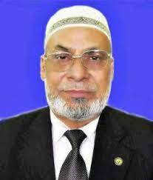
1. | Professor Dr. Md. Sultan Uddin Bhuiya (Retired)  Department of Agronomy  Bangladesh Agricultural University, Mymensingh.  Former Vice Chancellor  Ishakha International University  Date of Birth: 24/10/1950  Professional  Experience: Over 47 Years | PhD, 1983, Timirayezeb Agricultural Academy, Moscow, Russia  MSc, 1st Class, 1972, Bangladesh Agricultural University  BSc, 1st Class,1971, Bangladesh Agricultural University  HSC, 1st Class, 1968, Bangladesh Agricultural University  SSC, 2nd Division, 1966, Dhaka Board | Total number of article published in both National and International Journals: 183  Books / Monographs- 10  Research Projects: 16  International workshop attended: 11 | Membership: 10  # Bangladesh Association for the Advancement of Sciences.  # Bangladesh Agronomy Society  # Crop Science Society of Bangladesh  # Bangladesh Society for Horticultural Science  # Krishibid Institution of Bangladesh  # Bangladesh Agricultural Extension Society, Etc.

Sl. No. | Personal Information | Degree Achieved | Publications (Books / Journals) | Involvement with Professional Organization | Awards | 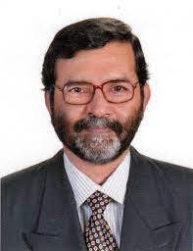
2. | Professor Dr. Sajal Krishna Banerjee (Retired)  Dept. of Cardiology  &  Chief, Clinical Cardiology Division, BSMMU,  Dhaka.  Date of Birth: 20/10/1955  Professional  Experience: Over 40 Years | FESC, 2006, European Society of Cardiology  FACC, 2004, American College of Cardiology  FCCP, 2003, American College of Chest Physicians  MD (Cardiology), 1991, Dhaka University  MBBS, 1981, Dhaka University  HSC, 1st Division, 1974, Jessore Board  SSC, 1st Division, 1972, Jessore Board | Total number of article published in both National and International Journals: 131  Review Articles : 13  Abstracts : 36  Research  Projects : 10  Ongoing Research  Projects: 03  Case Report:12  Editorials: 3  Scientific Conference Attended: 2 | Membership: 05  # Bangladesh Medical Association  # Bangladesh Cardiac Society  # Bangladesh Association of Physicians  #Bangladesh Chest & Heart Association  # Bangladesh society of Echocardiography, Etc. | # Mahatma Gandhi Peace Award  # Bangladesh Cultural Foundation Gold Medal Award  # Probin Kallyan Parishad Award  # Rotary Club of Dhaka Central (Rorary International) Award  # Best of American College of Cardiology Award 2012 & 2017

Sl. No. | Personal Information | Degree Achieved | Publications  (Books / Journals) | Involvement with Professional Organization | Awards | 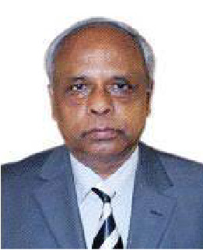
3. | Professor Dr. Shariff Enamul Kabir (Retired)  Former Professor  Department of Chemistry  Jahangirnagar University,  Savar  Former Member  Bangladesh Public Service Commission, Dhaka  Former Vice Chencellor  Jahangirnagar University,  Savar  Date of Birth- 28/02/1955  Professional  Experience- Over 41 Years | PhD in Chemistry, 1986, University College London, UK (London University)  MSc in Chemistry,  1st Class, 1976, Jahangirnagar University, Savar, Dhaka  BSc in Chemistry,  1st Class, 1975, Jahangirnagar University, Savar, Dhaka  HSC, 1st Division, Dhaka Board  SSC, 2nd Division, Dhaka Board | Total number of article published in both National and International Journals: 366  Research Collaboration with foreign University: 12  Editorial  Activity: 05 | Membership: 05  # Bangladesh Academy of Science  # Bangladesh Chemical Society  # Bangladesh Association for the Advancement of Sciences  #American Chemical Society  # The Royal Society of Chemistry | # University Grants Commission Award in 1990 & 2011 (UGC)  # Research Fund Award in 1993, 1994 & 1995 (The Royal Society of Chemistry)  # Gold Medal (Senior Group) in 1998 (Bangladesh Academy of Sciences)  #M. O. Ghani Gold Medal Award in 2008 (Bangladesh Academy of Sciences)  #International Gold Medal Award in 2017 (Dr. M. A. Wazed Miah Memorial Science Foundation)  # United Group Outstanding Research Paper Award in 2017

